**DAILY ONLINE ACTIVITIES SUMMARY**

|  |  |  |  |  |  |  |  |
| --- | --- | --- | --- | --- | --- | --- | --- |
| **Date:** | | **29/5/2020** | | | | | |
| **Name of the Faculty** | | **REENA LOBO** | | | | | |
| **No. of Students Allotted for monitoring** | | | | | **19** | | |
| **Progress** | | | | | **GOOD** | | |
| **Whether collected report from all the allotted students** | | | | | **16** | | |
| **Online Test Summary** | | | | | | | |
| **Subject** |  | | | | | | |
| **Semester** |  | | | **Duration** | |  | |
| **No. of students Taken** | | |  | **Passing %** | |  | |
| **Certification Course Summary** | | | | | | | |
| **Course** | | Attended webinar on The Future of Artificial Intelligence, **Certificate provider: ICT ACADEMY** Duration of the course: 1hr2. Attended Webinar on MACHINE LEARNINGCertification provider: CAMBRIDGE INSTITUTE OF TEHNOLOGY **Duration of the course:2hr**  **3.Attended webinar on cyber security**  **Certification provider:** **CAMBRIDGE INSTITUTE OF TEHNOLOGY** Duration of the course:2hrs.. | | | | | |
| **Certificate Provider** | |  | | | **Duration** | |  |
| **Coding Challenges** | | | | | | | |
| **We are given 3 strings: str1, str2, and str3. Str3 is said to be a shuffle of str1 and str2 if it can be formed by interleaving the characters of str1 and str2 in a way that maintains the left to right ordering of the characters from each string. For example, given str1="abc" and str2="def", str3="dabecf" is a valid shuffle since it preserves the character ordering of the two strings. So, given these 3 strings write a function that detects whether str3 is a valid shuffle of str1 and str2.** | | | | | | | |
| **Status: completed** | | | | | | | |
| **Uploaded the report in Github** | | | | | **yes** | | |
| **If yes Repository name** | | | | | <https://github.com/reenalobo/ONLINE-ACTIVITY-REPORT/upload/master> | | |
| **Uploaded the report in slack** | | | | | **yes** | | |

Certification Course Details: (Attach the snapshot and briefly write the report for the same)

**Attended webinar on The Future of Artificial Intelligence**

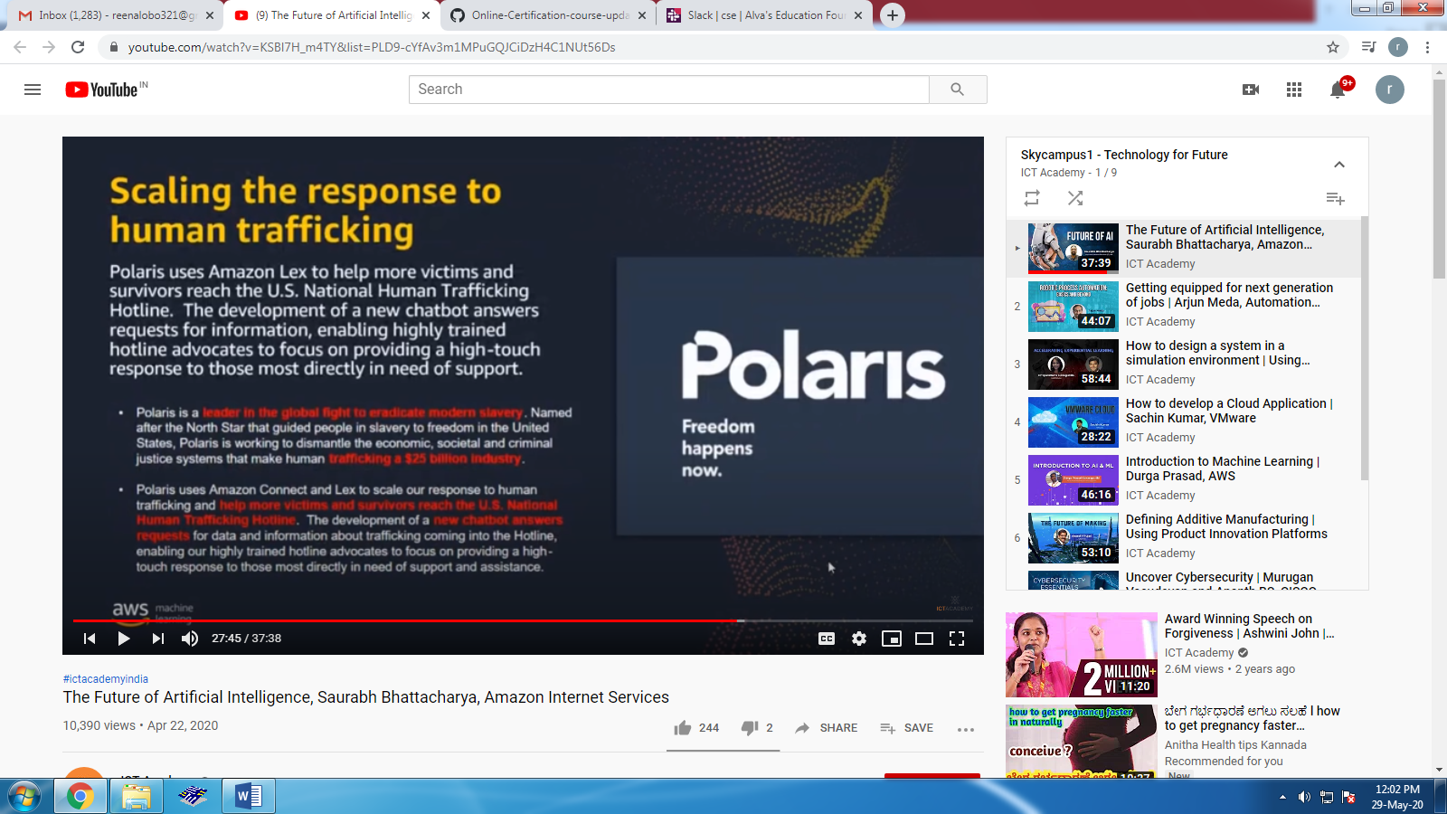

**Attended Webinar on MACHINE LEARNING:**

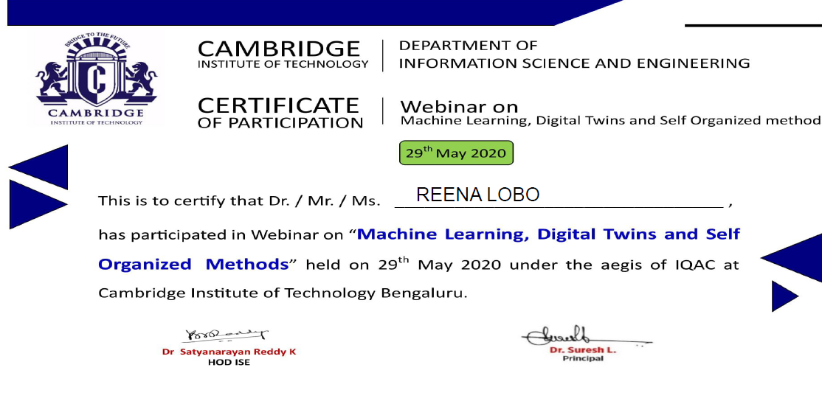

**Coding activity:**

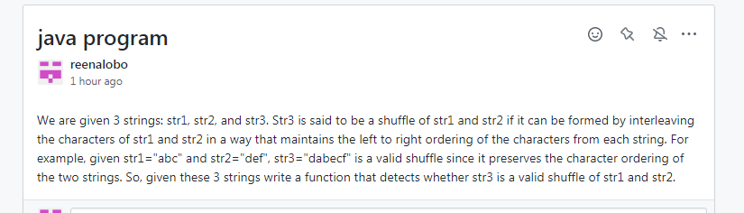

STUDENTS REPORT:

ROHAN MAHAVEER:

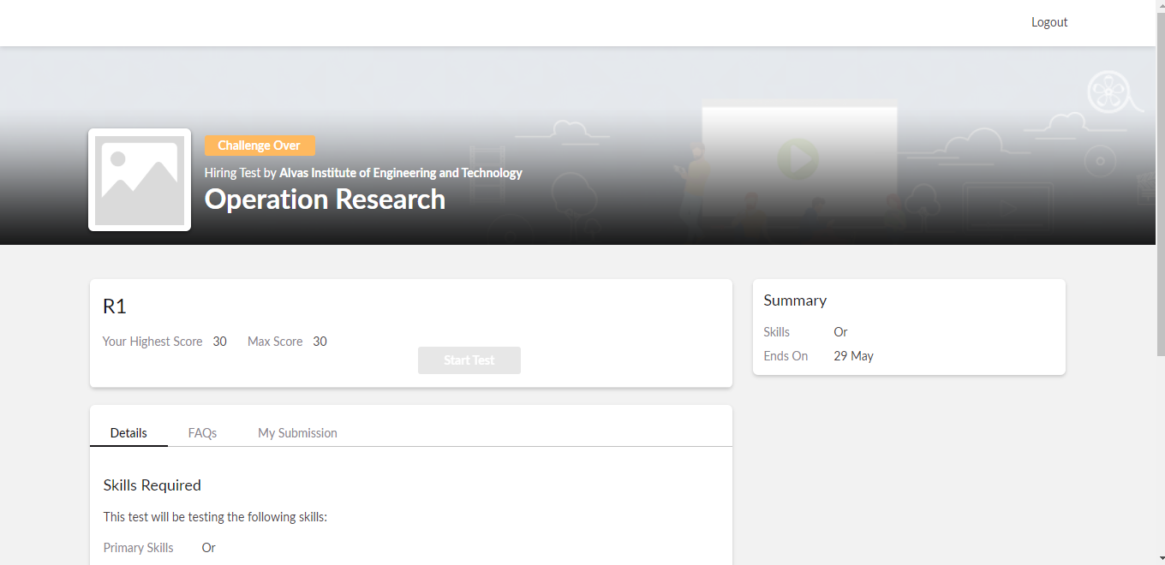

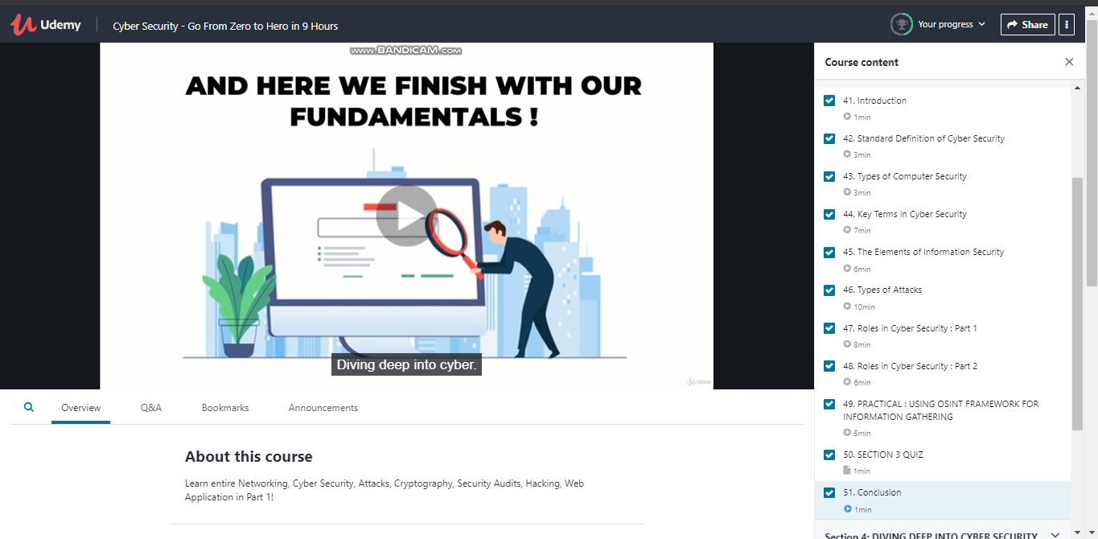

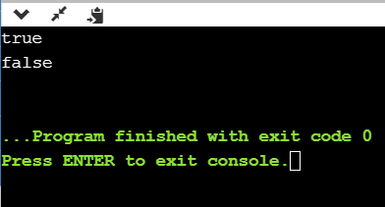

ATISH:

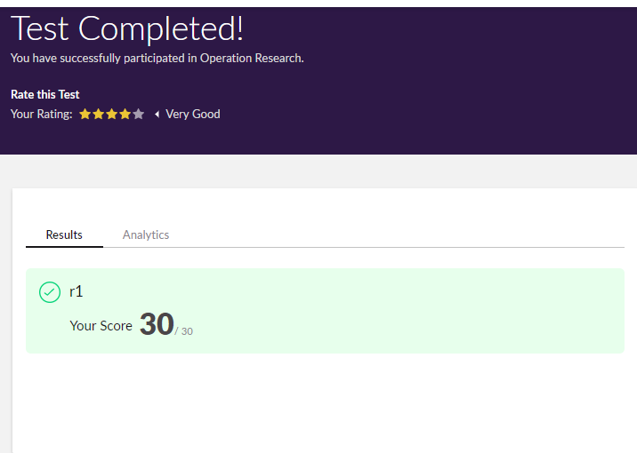

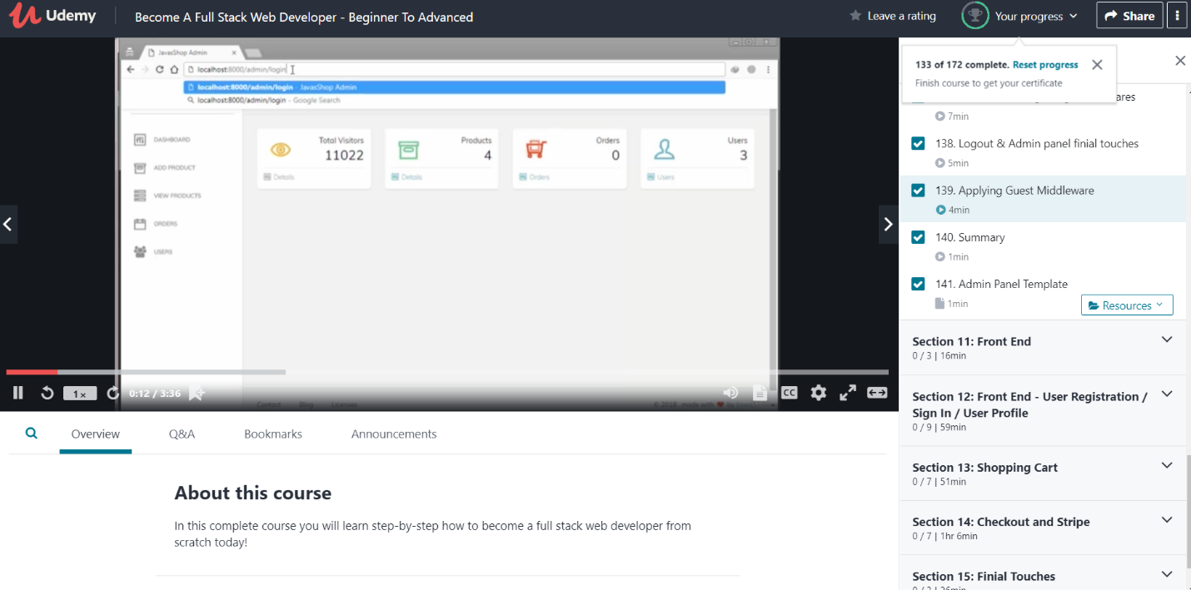

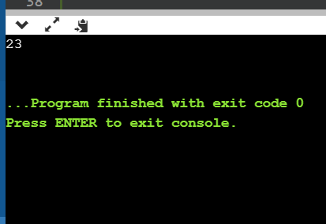

**Shah Dhruvil Amit:**



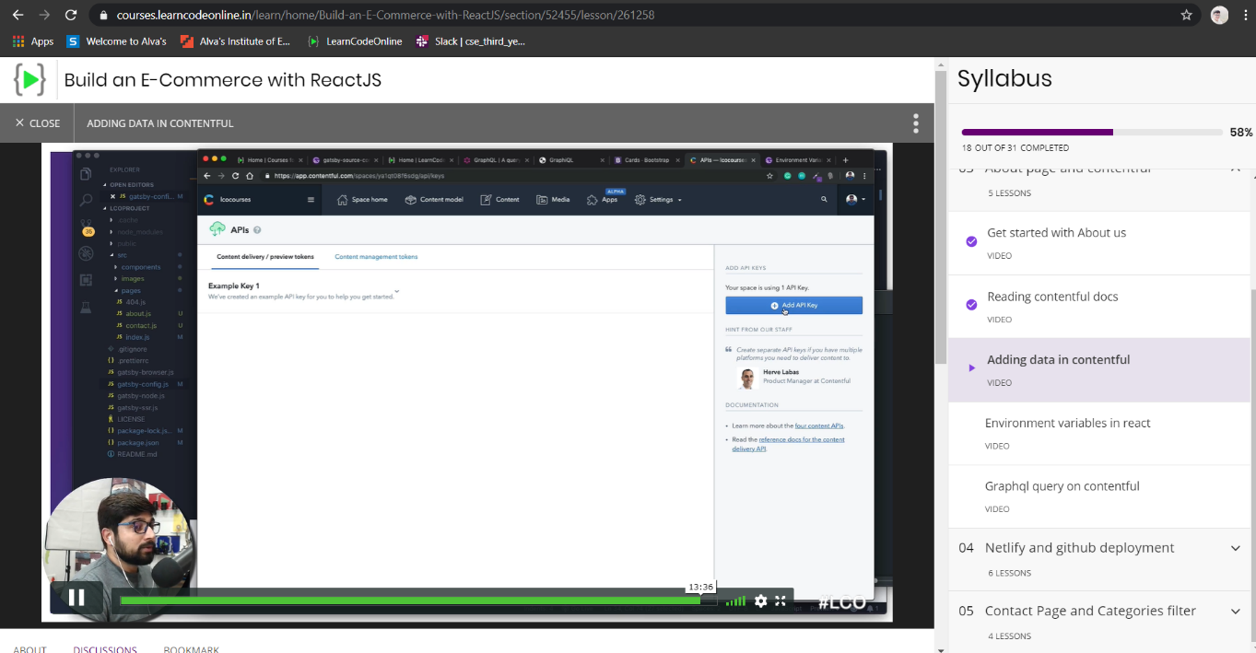

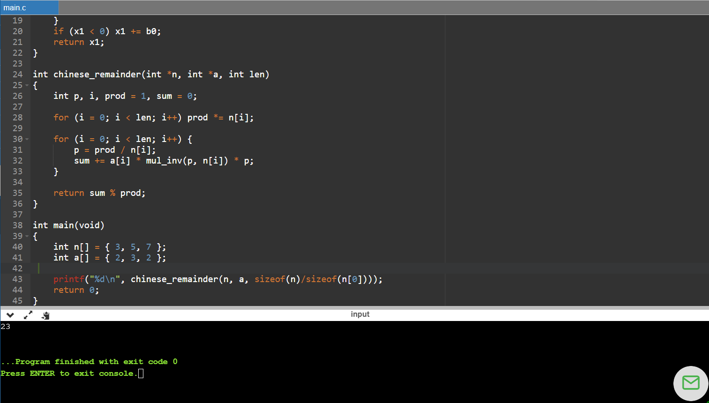

**Raksha S:**

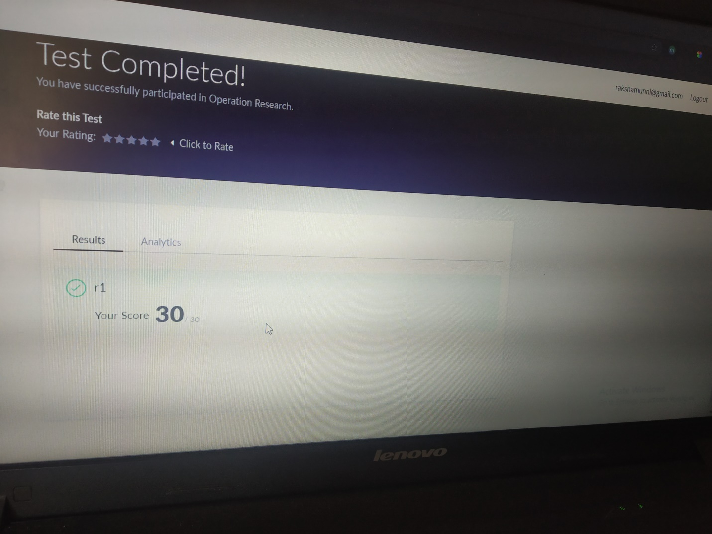

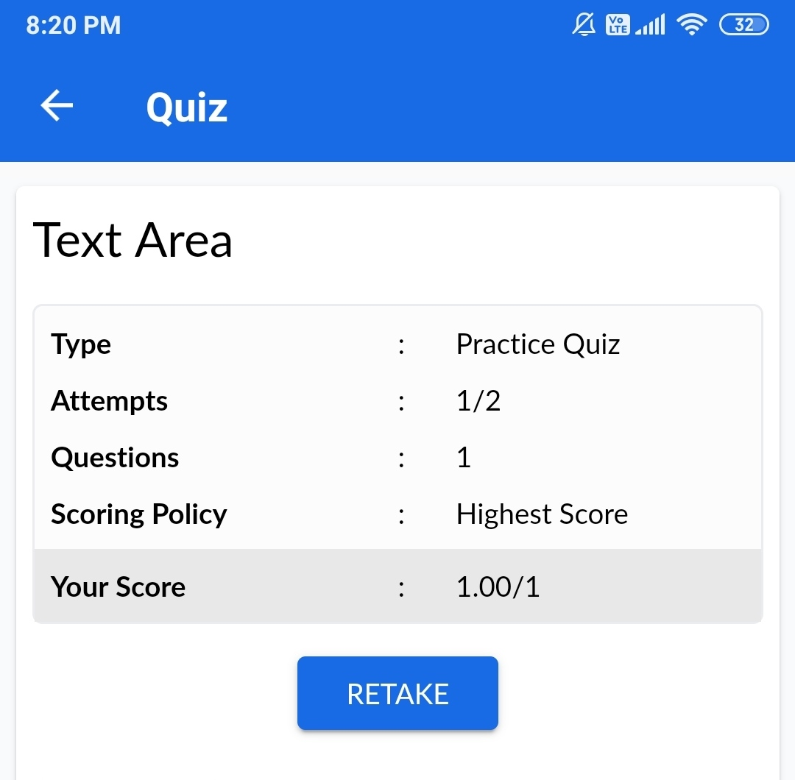



**Preethi:**

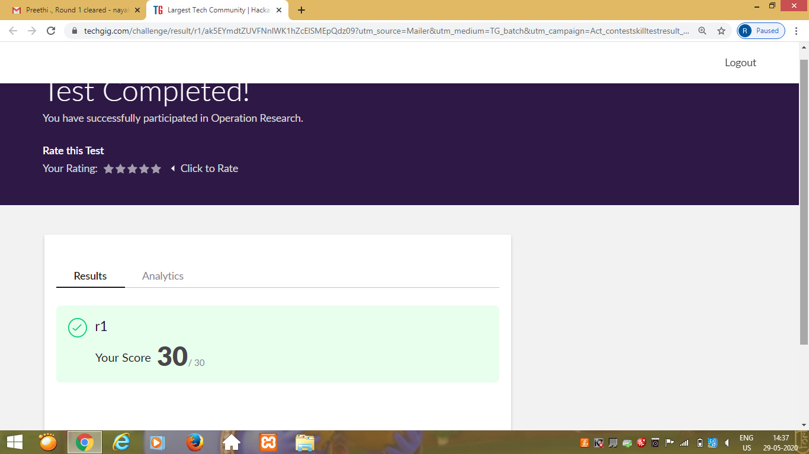

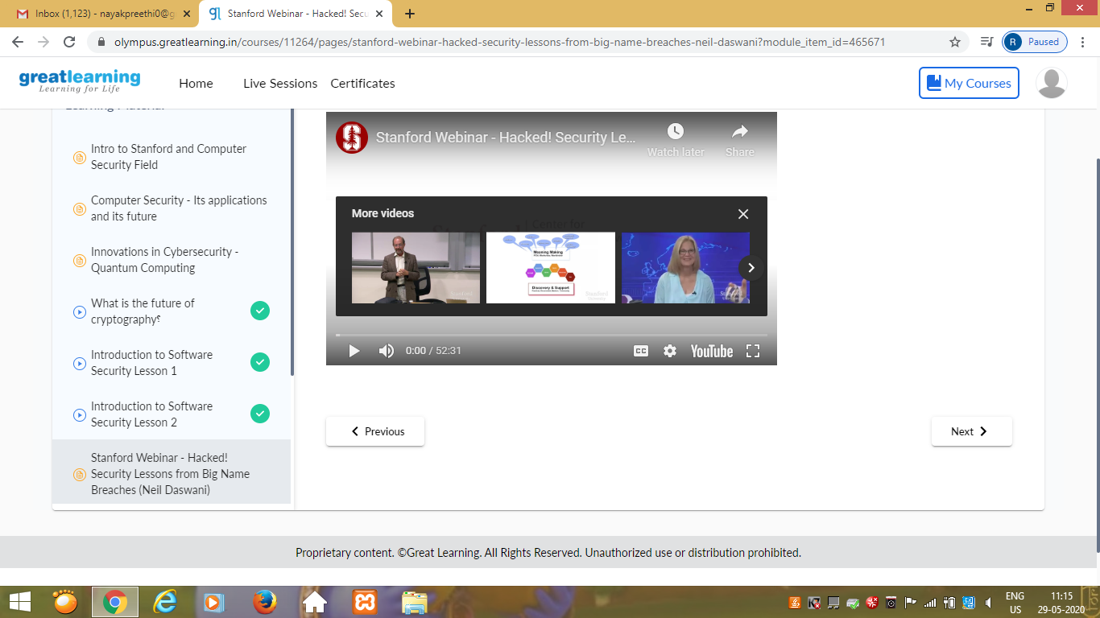

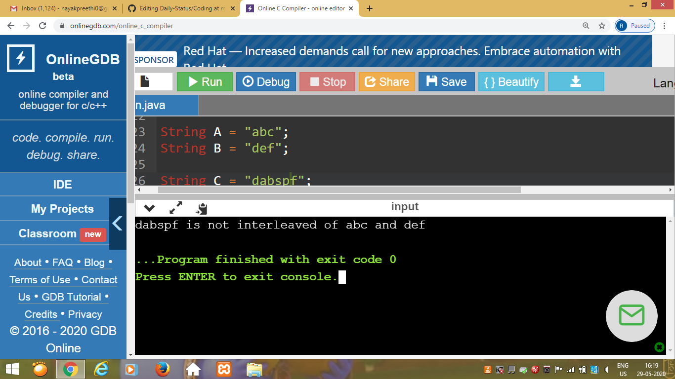

Rani:

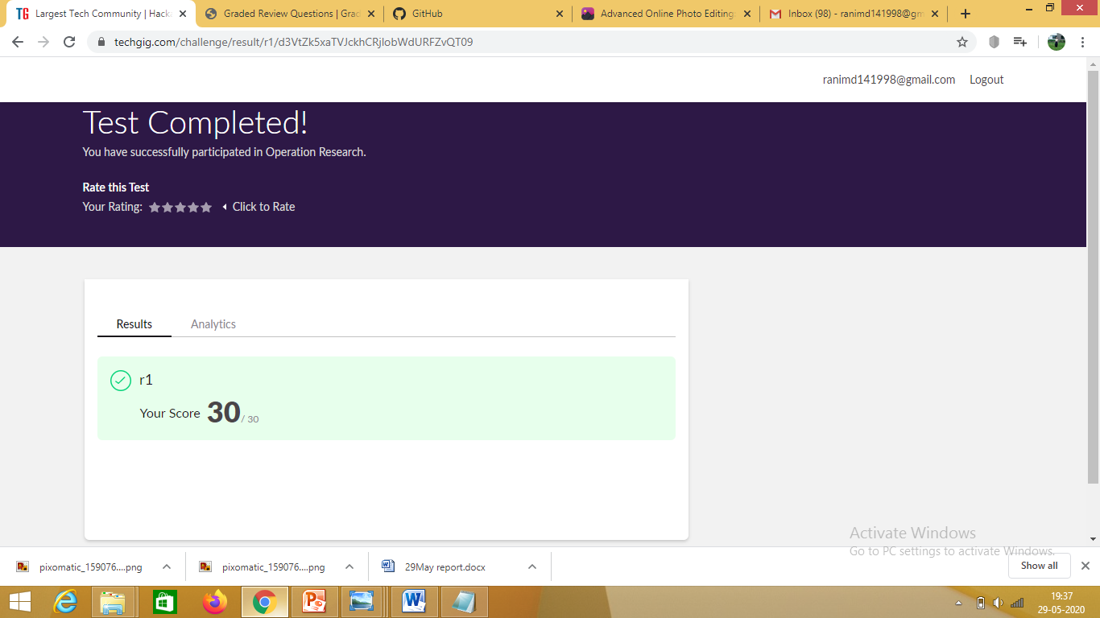

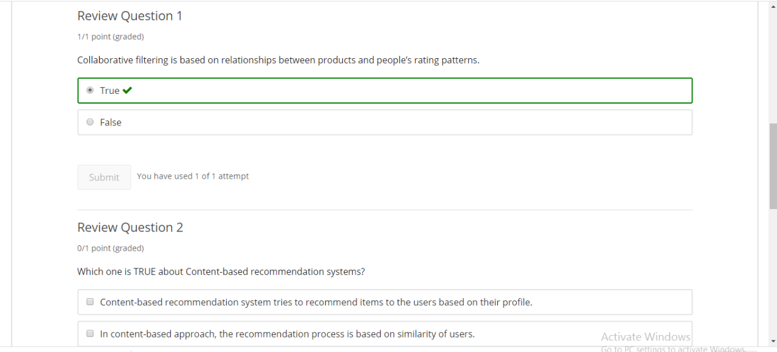



**Pranav L M:**

Online Test Details:

SECOND I A of OR

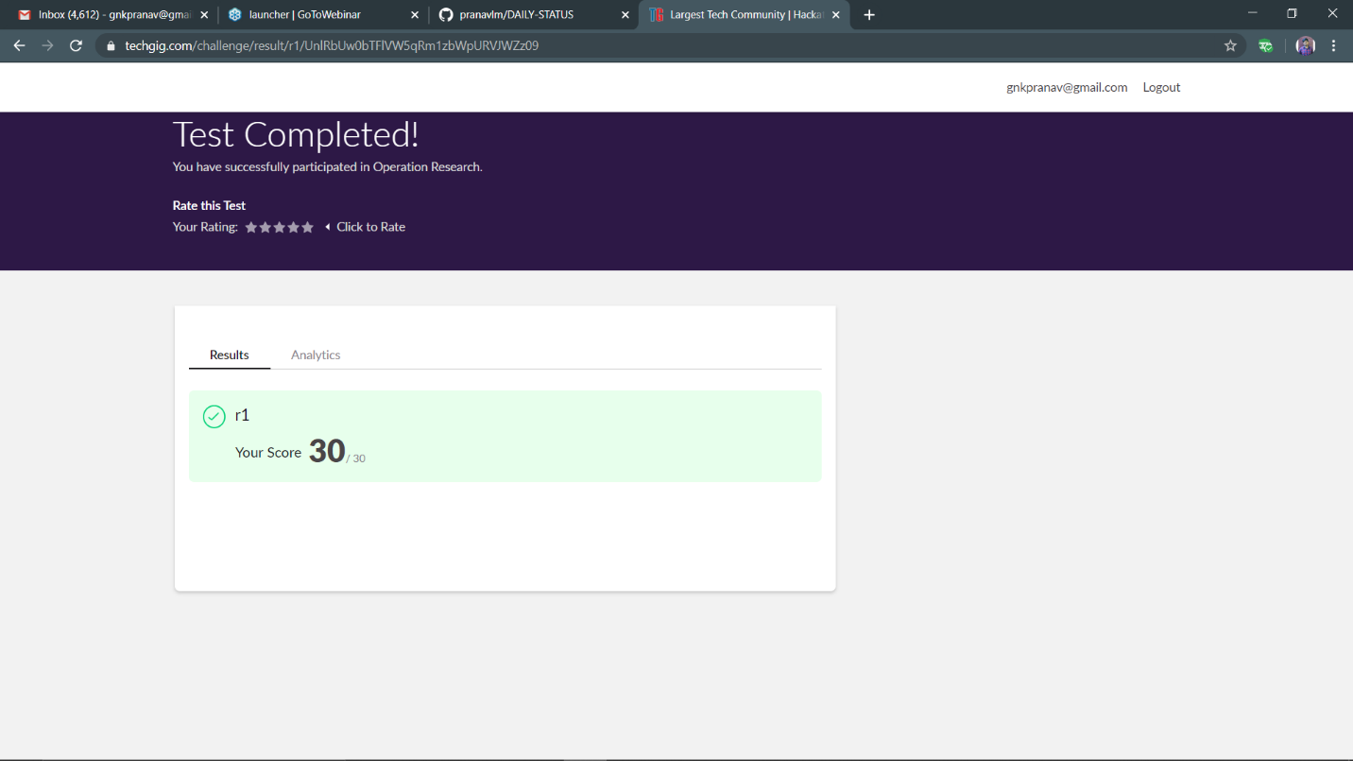

Certification Course Details:

Module-II

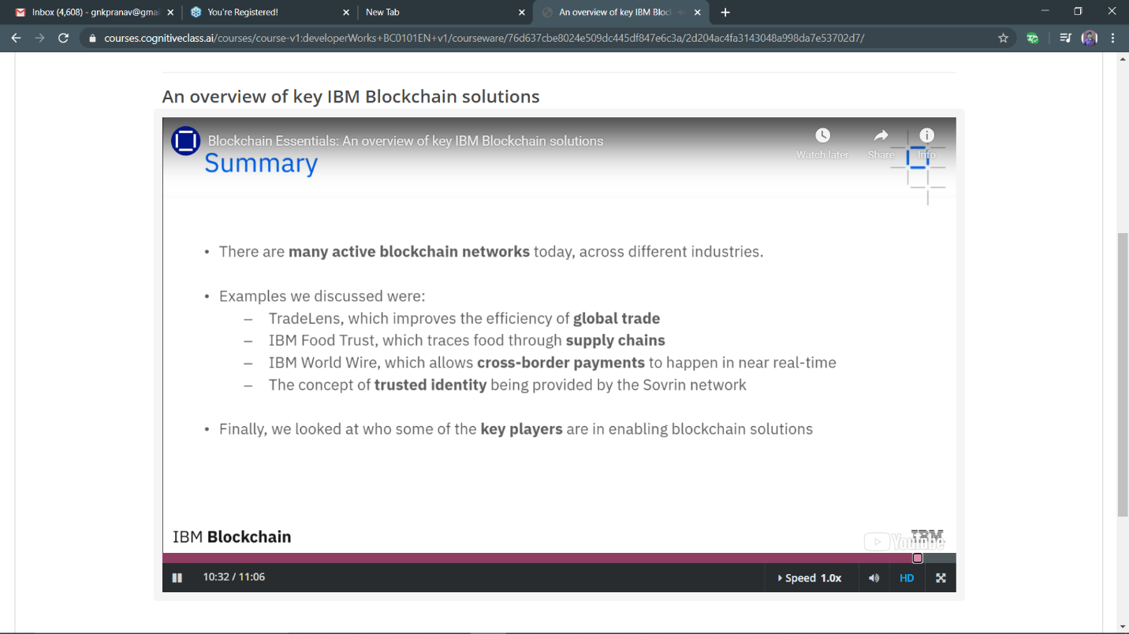

Progress:

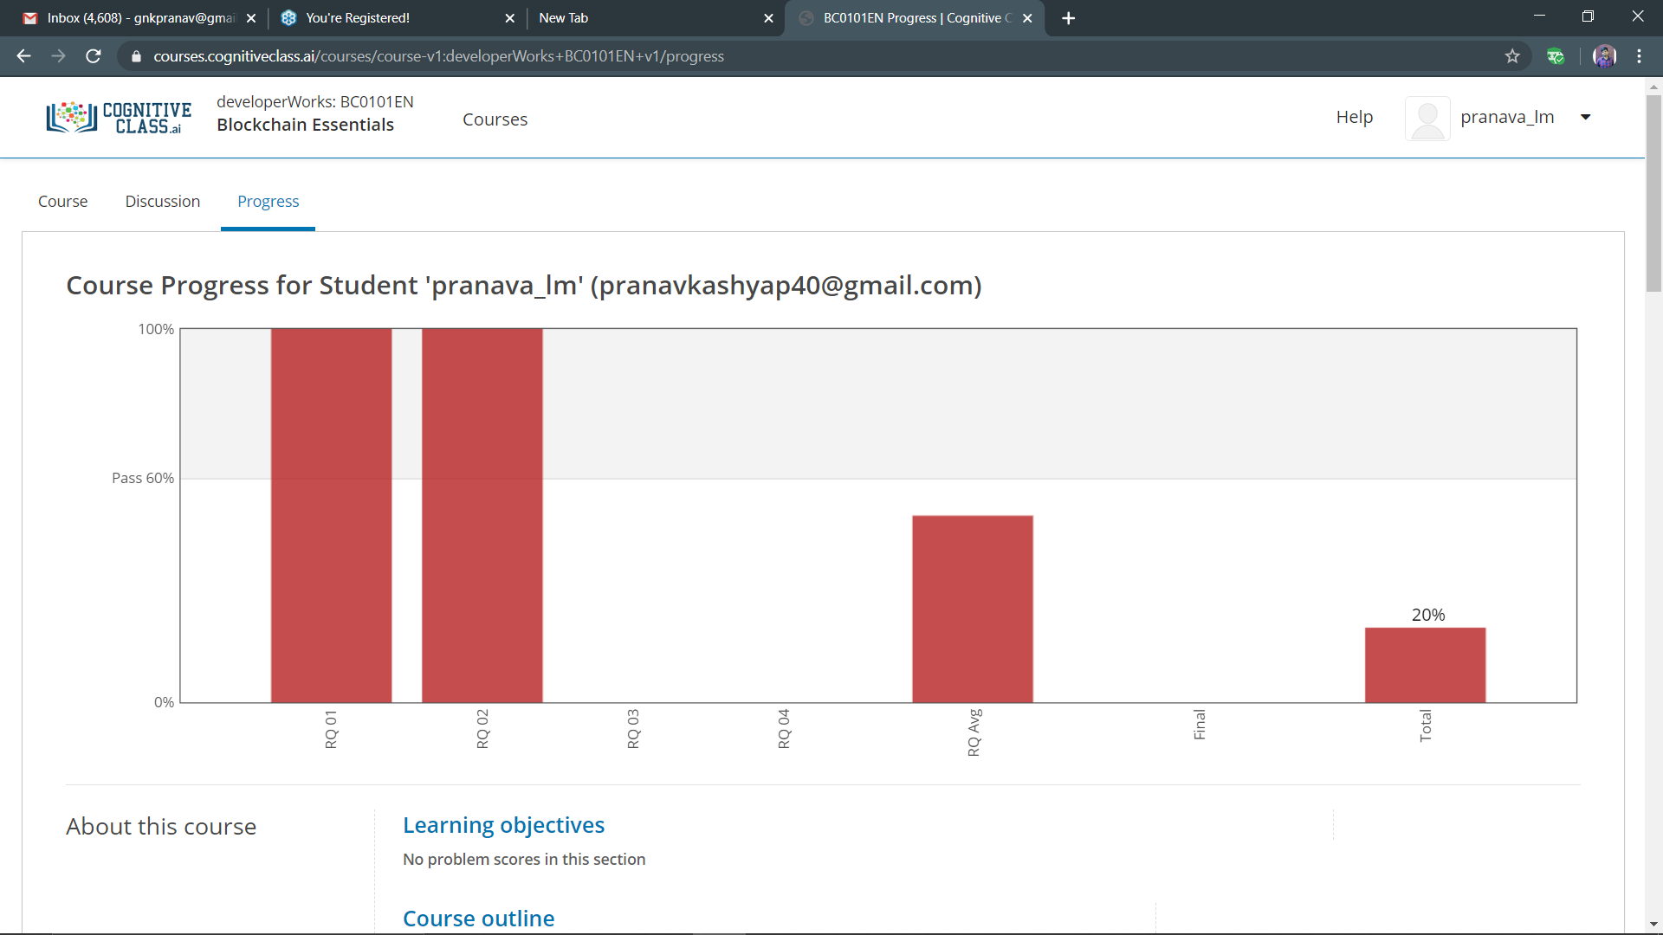

Coding Challenges Details:

**P-1**

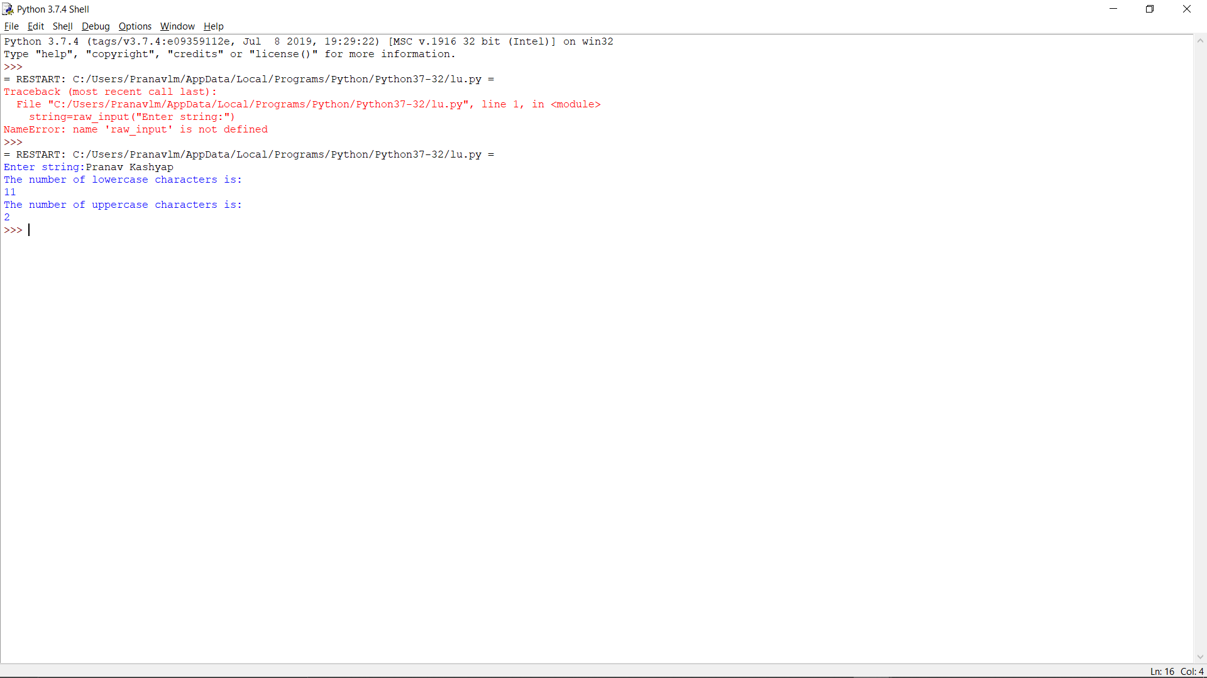

RAVALI:

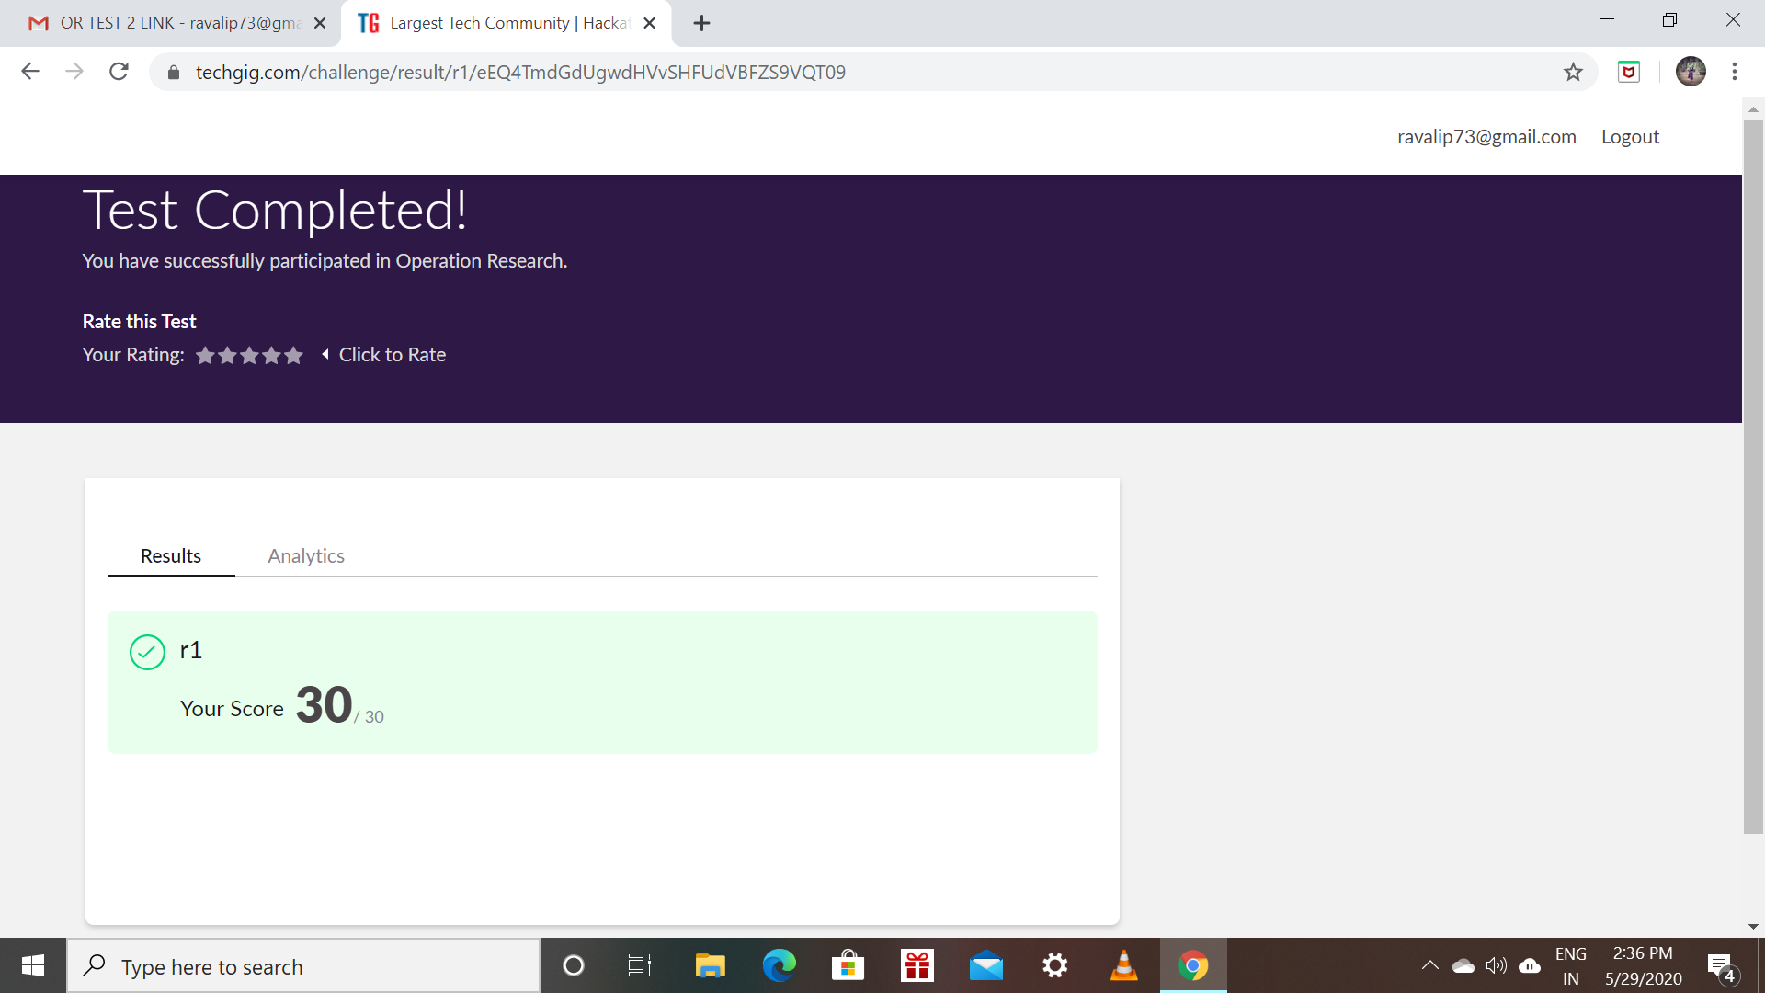

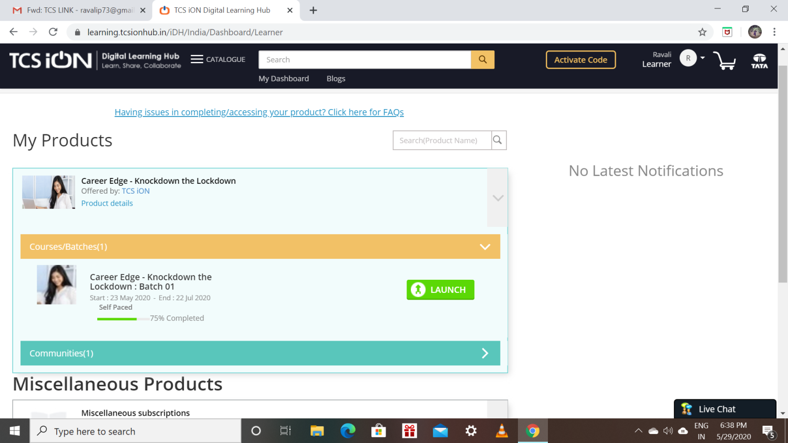

Priyanka:

**Online Test Details:**

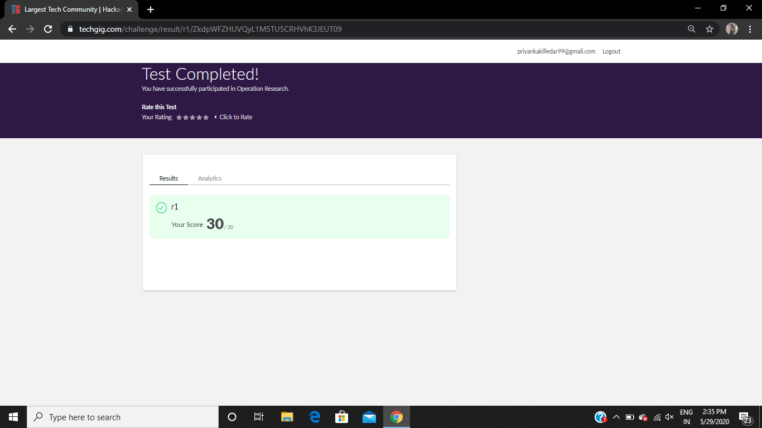

**Certification Course Details:**

**Today Progress:**

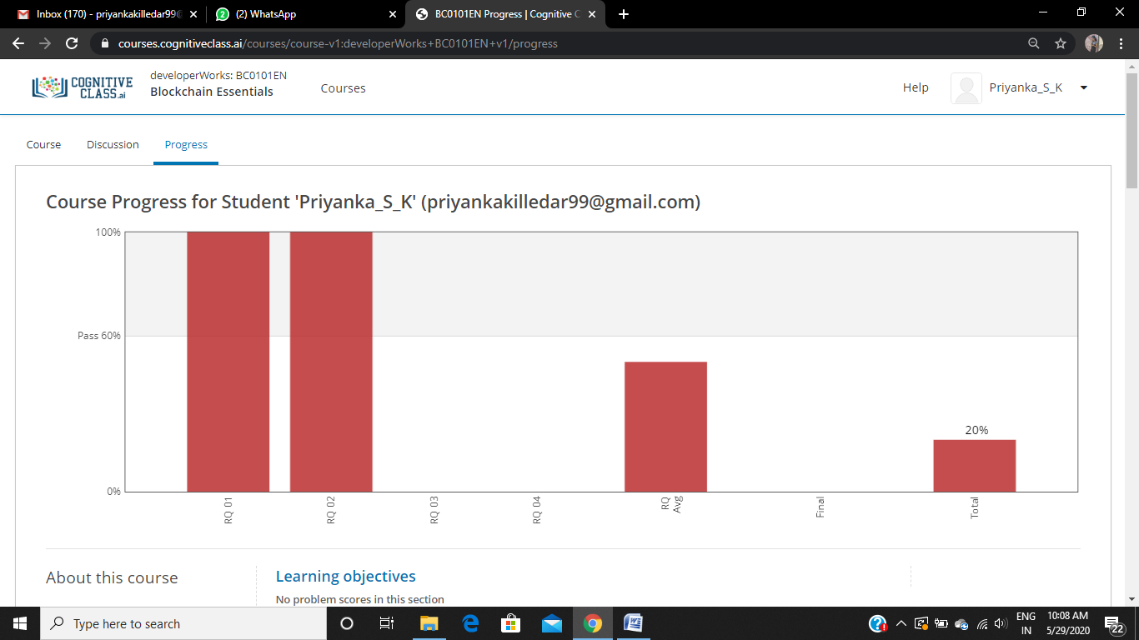

I solved the review question on module 2 and above screenshot is the progress of 2nd module .

**Coding Challenges Details:**

Refer the github link for detail information :<https://github.com/Priya-s-k/Online-coding-updates>

Solved all the problems and the solutions are uploaded in github account.

The same report is also available in github: <https://github.com/Priya-s-k/online-activity-updates>

Priya:

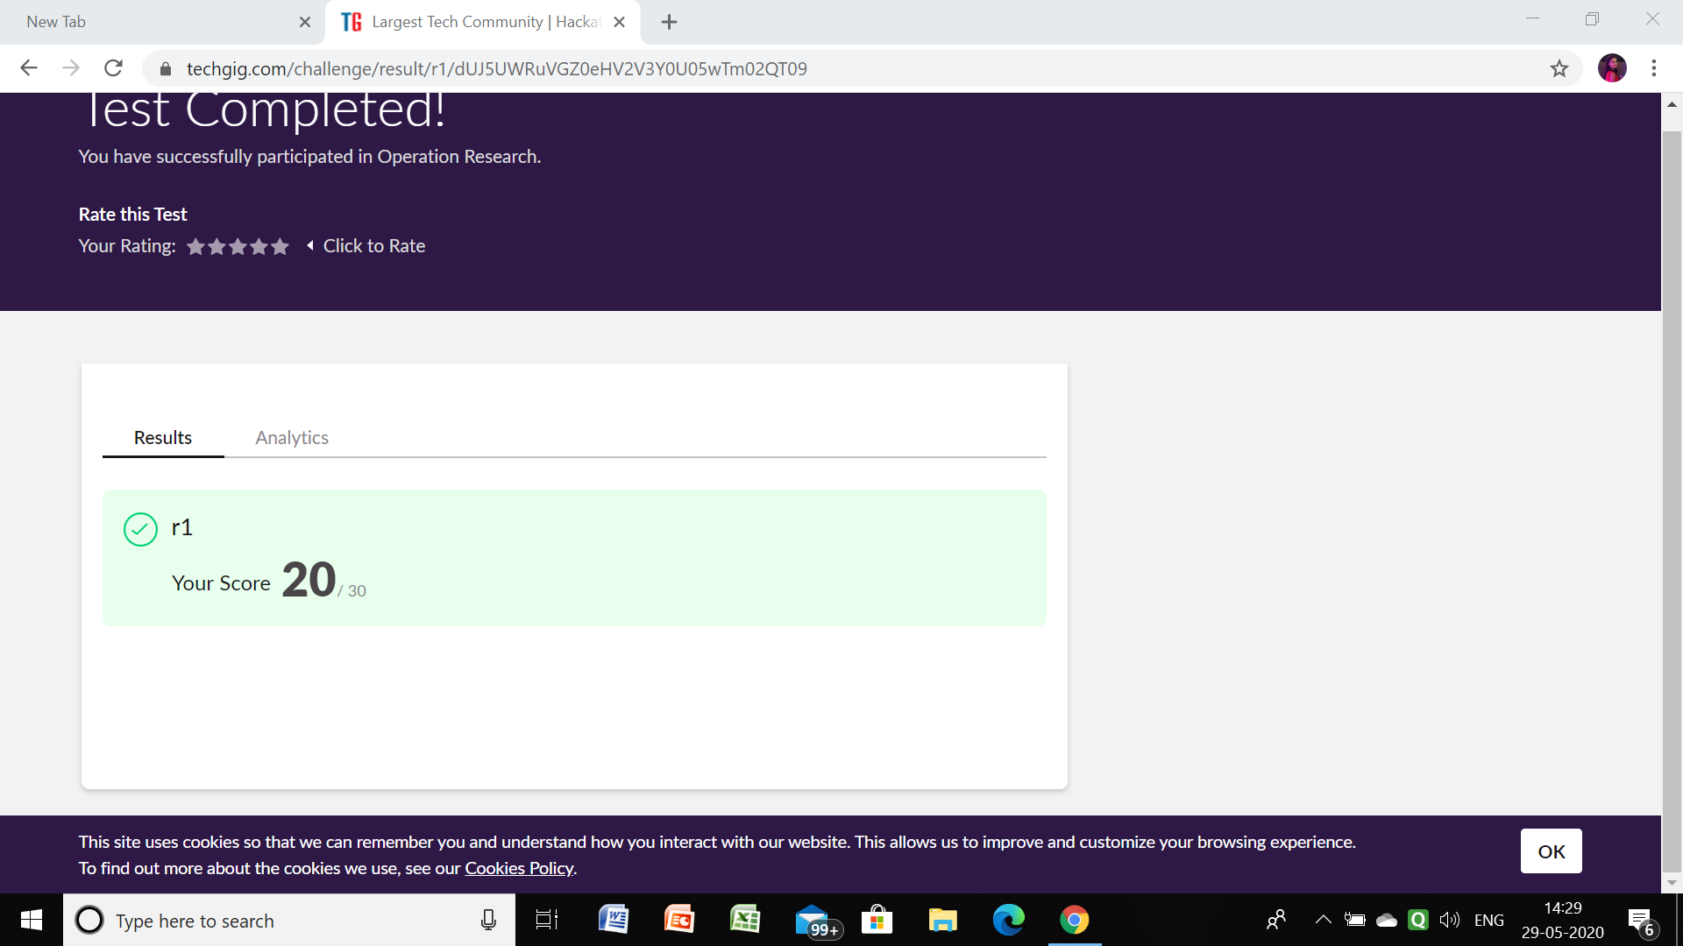

Github link for detail information: <https://github.com/priya3028/Onlinecodingupdate>

Solved and uploaded in github

Rousha:

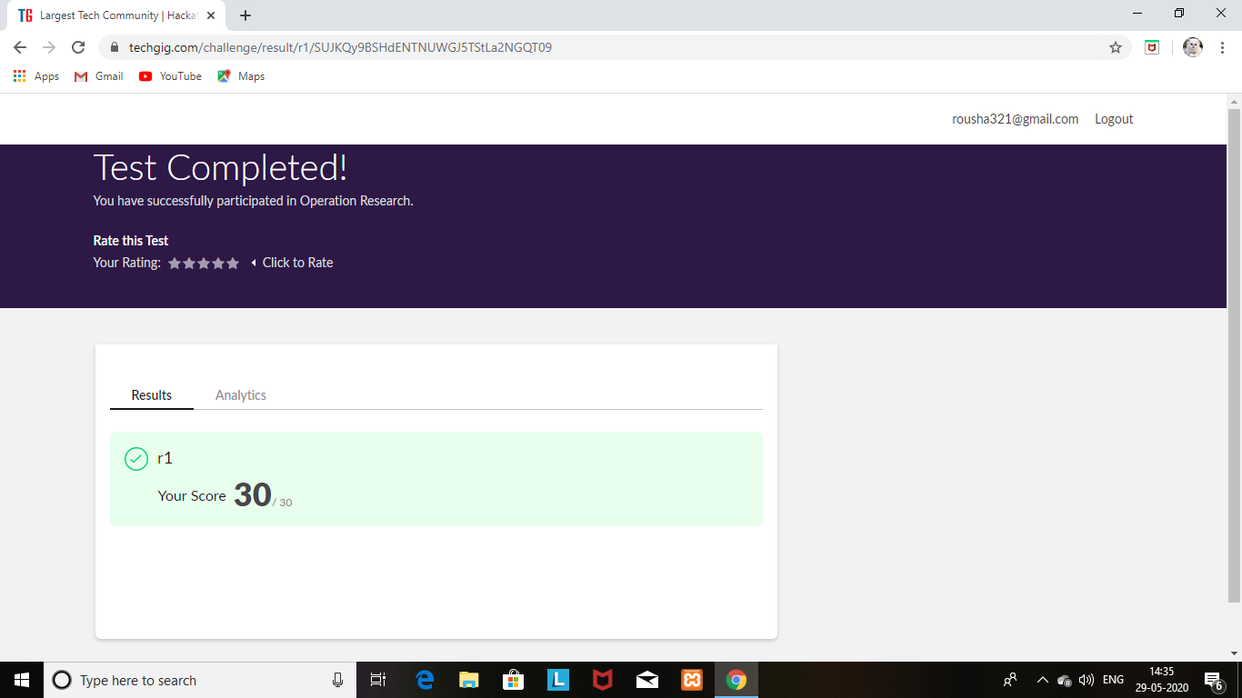

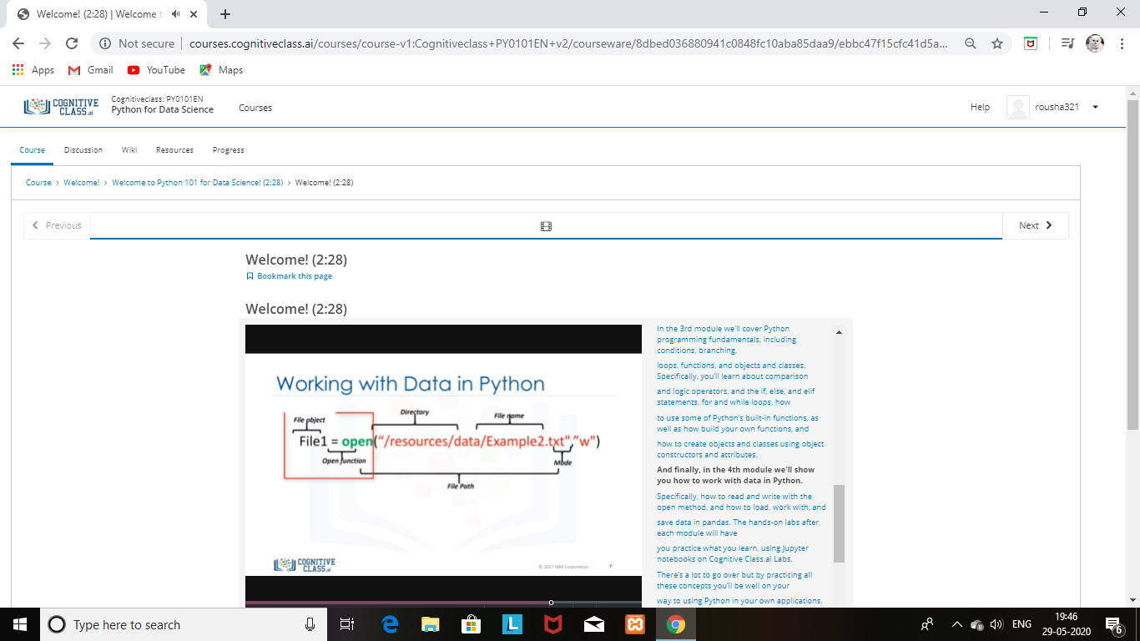

SHAIFA:

for the same)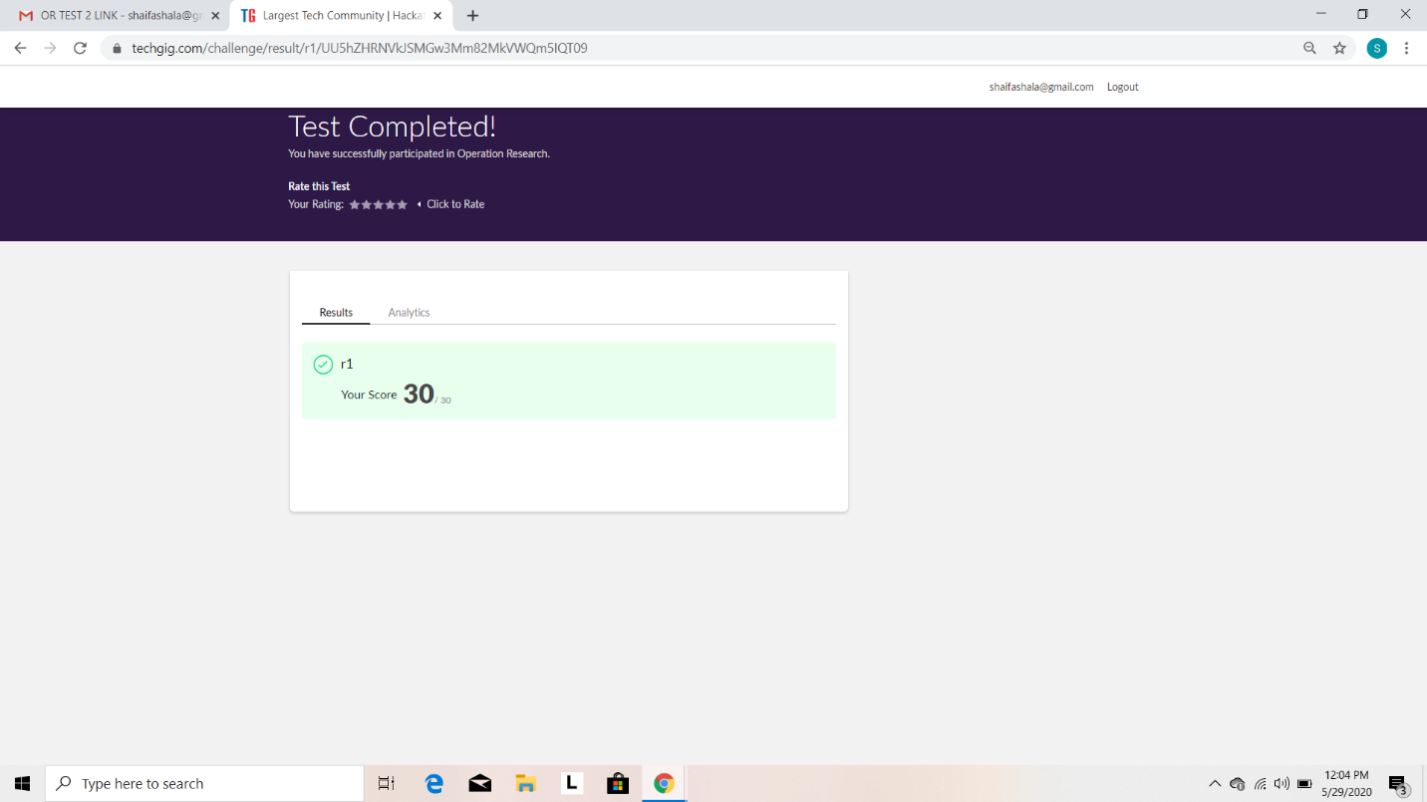

Certification Course Details: (Attach the snapshot and briefly write the report for the same)

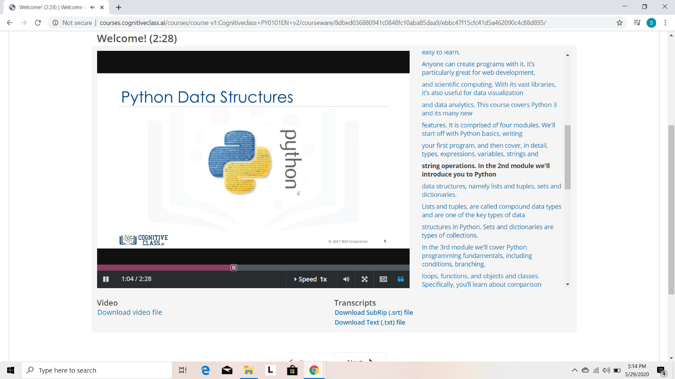

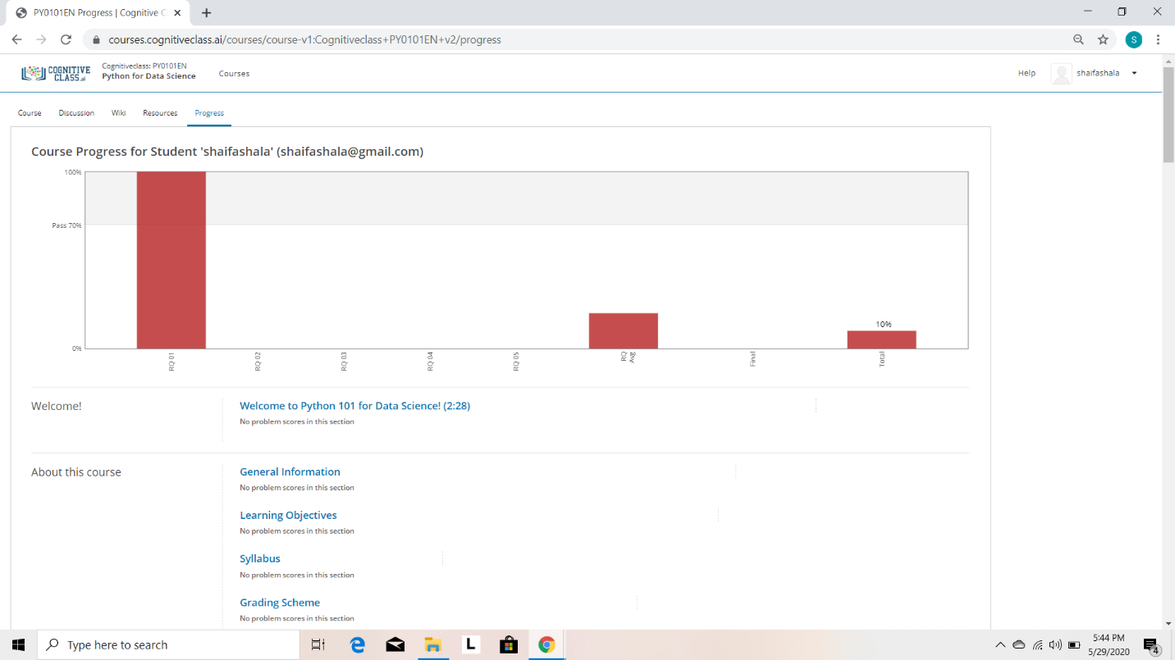

Rani:





Sana:

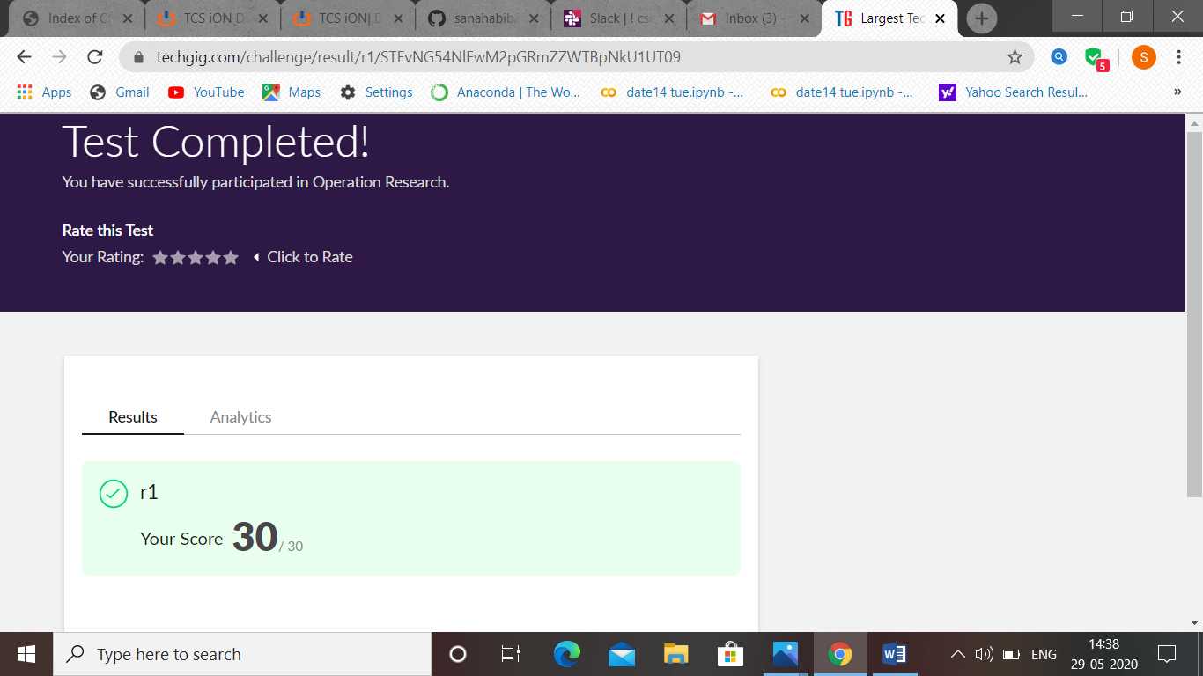

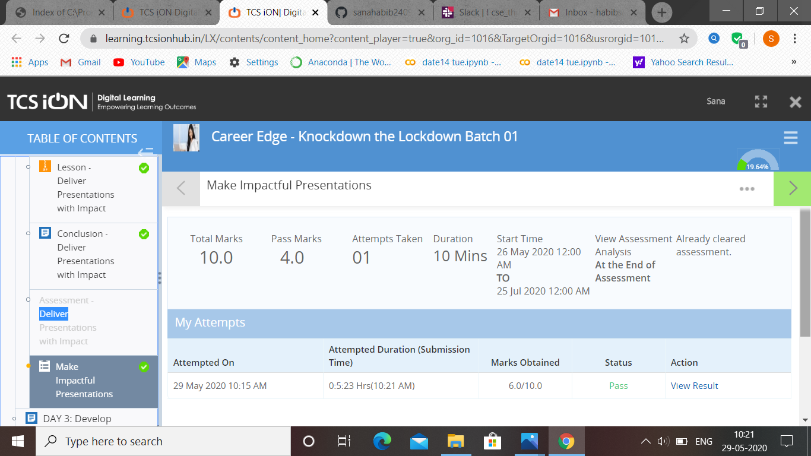

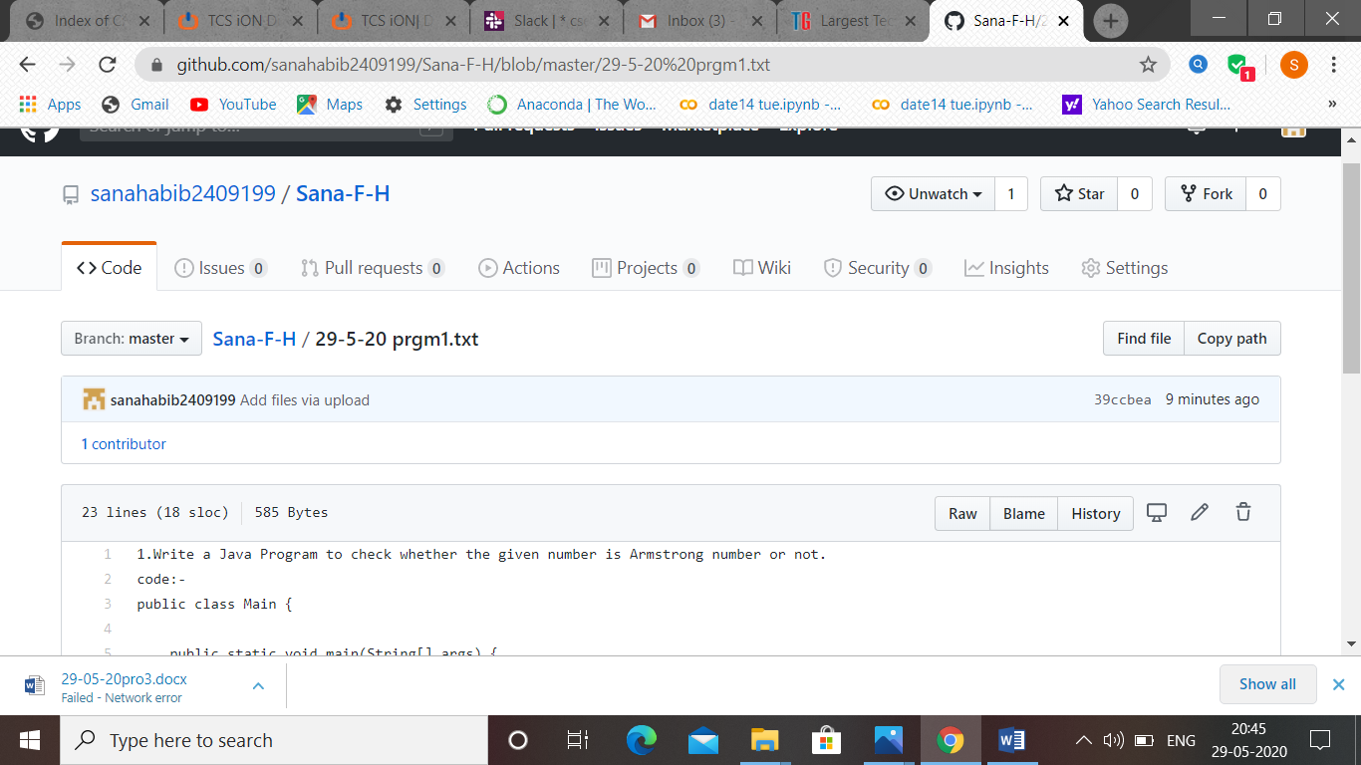

Rachana:

**Online Test Details:**

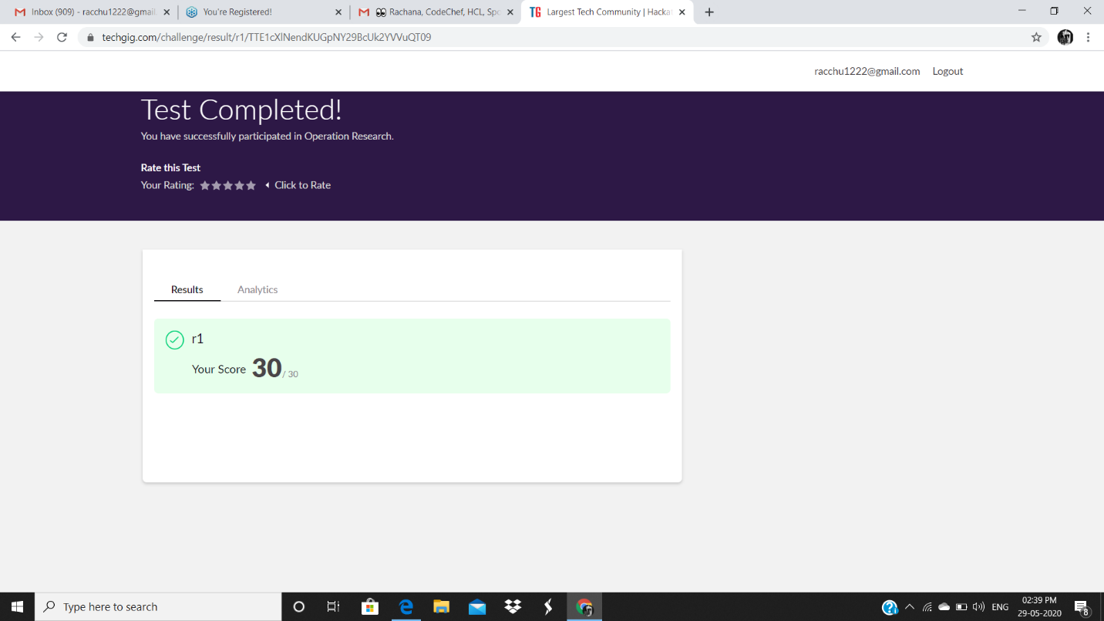

**Certification Course Details:**

**Today Progress:**

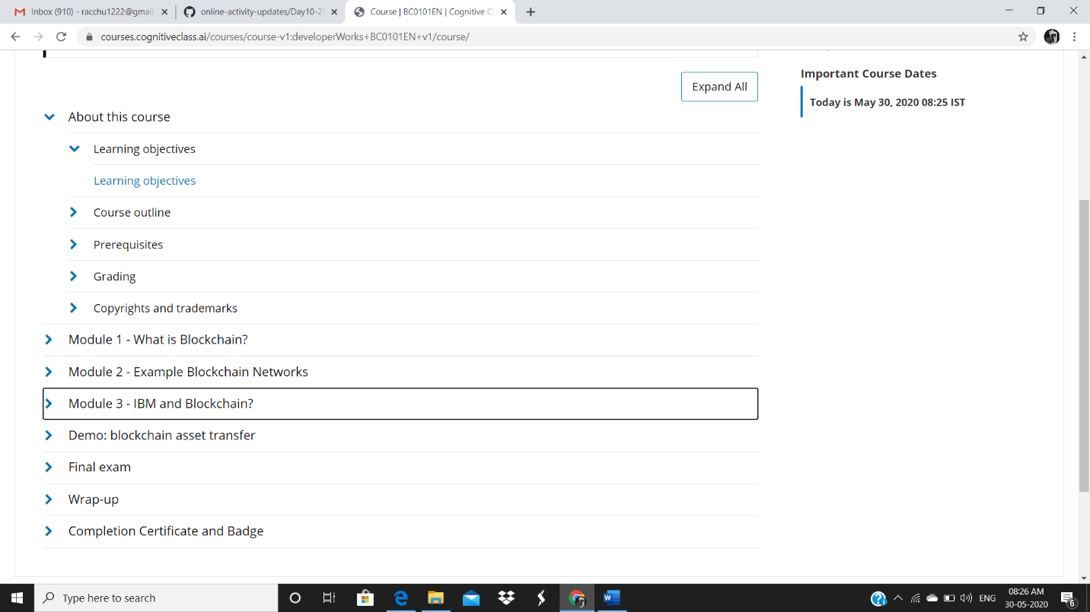

Raghavi:

